**Lab 1**

5. Copy the /etc/passwd file to your home directory

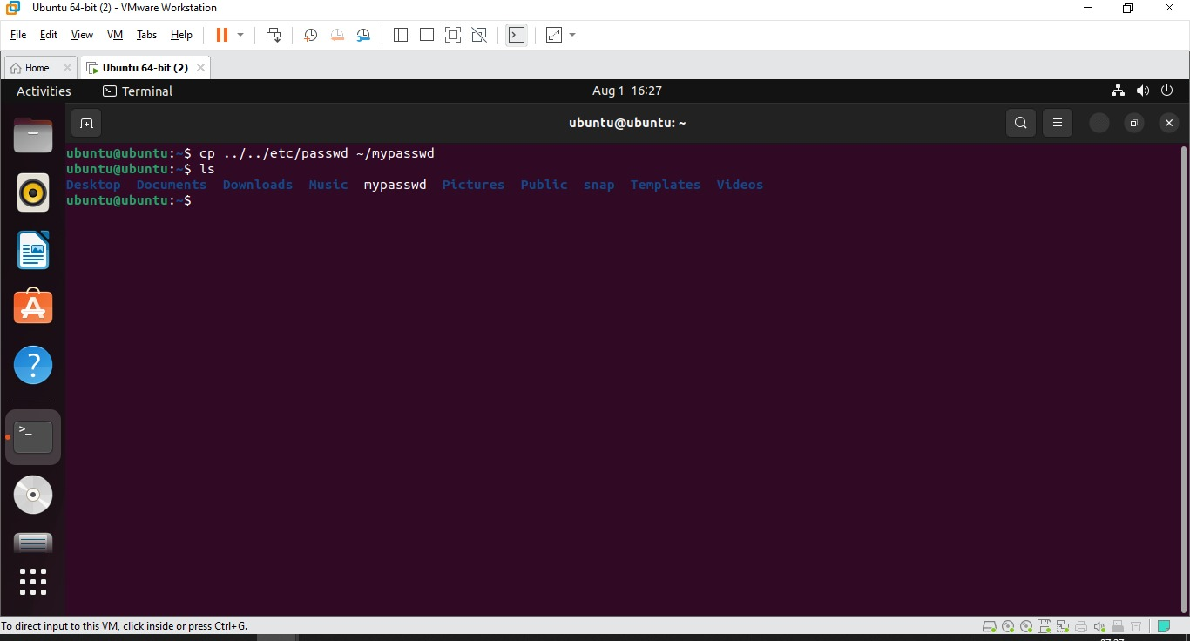

6. Rename this new file to be oldpasswd.

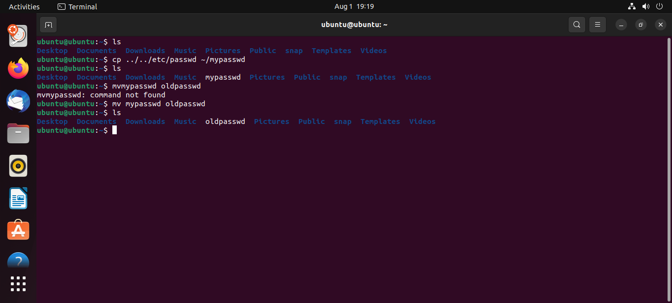

8. List Linux commands in /usr/bin that start with letter w

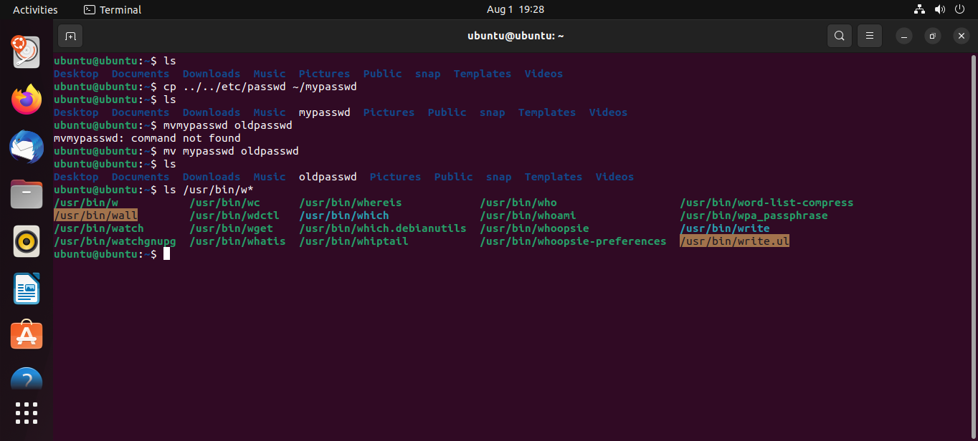

11.Display the man pages of passwd the command and the file sequentially in one command.

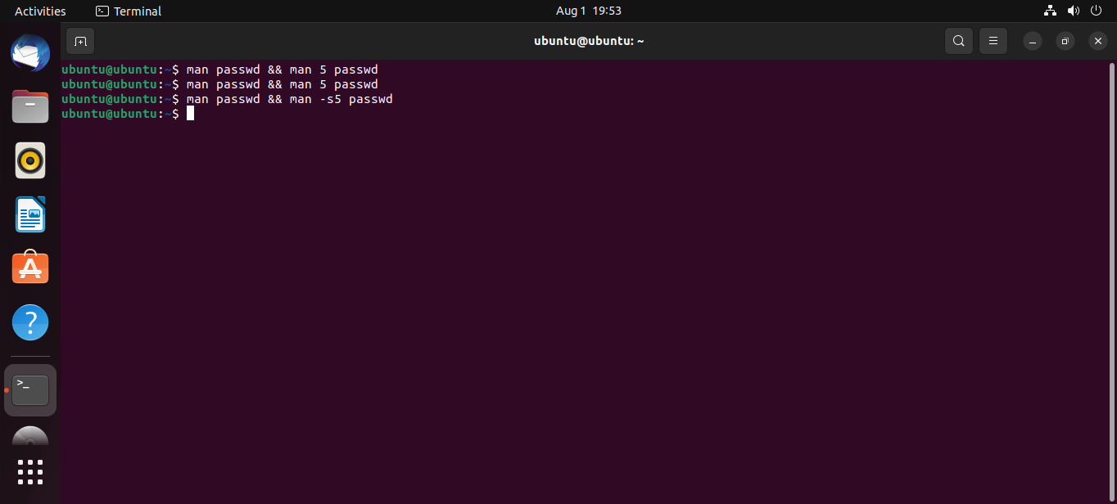

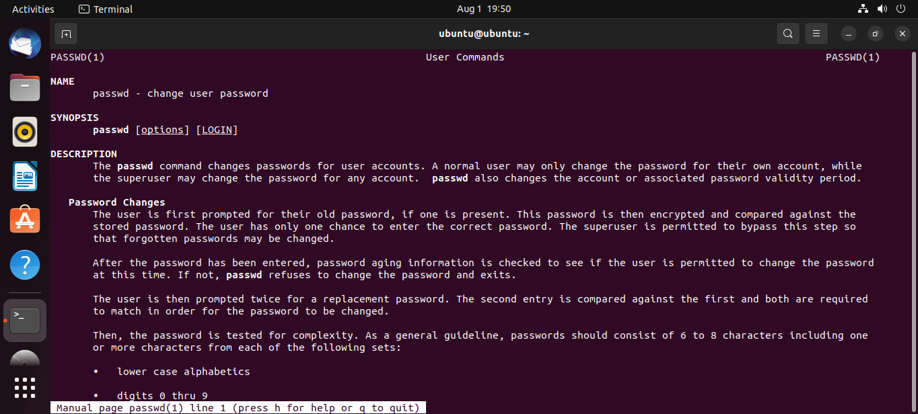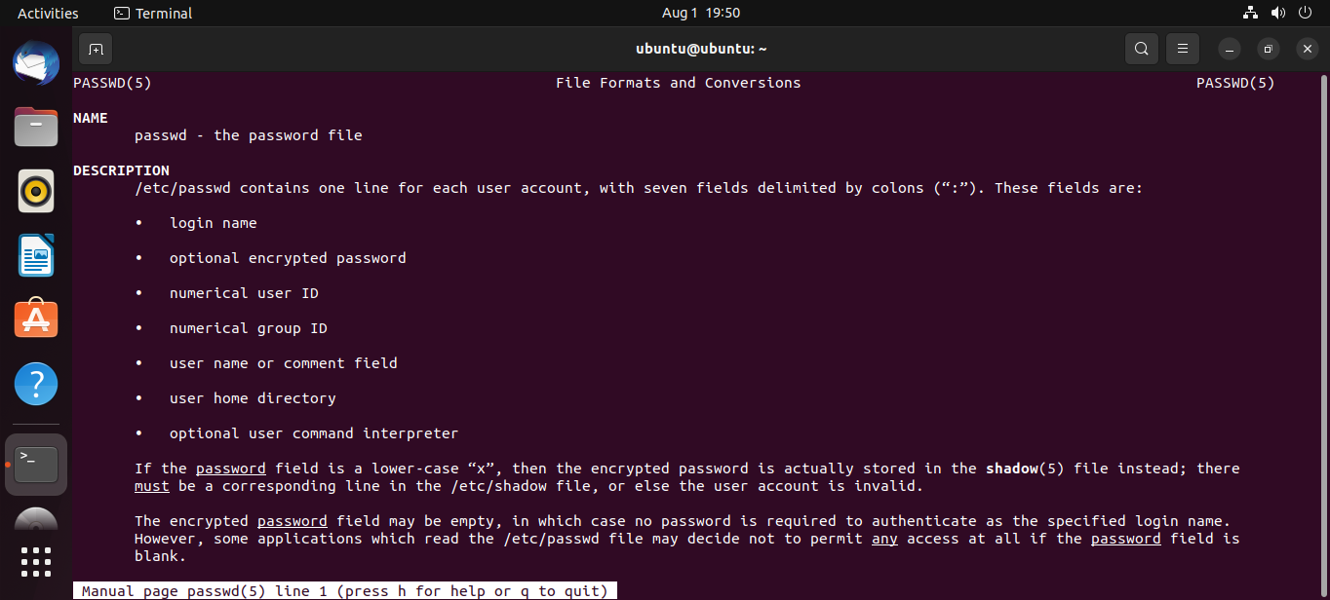

12.Display the man page of the passwd file.

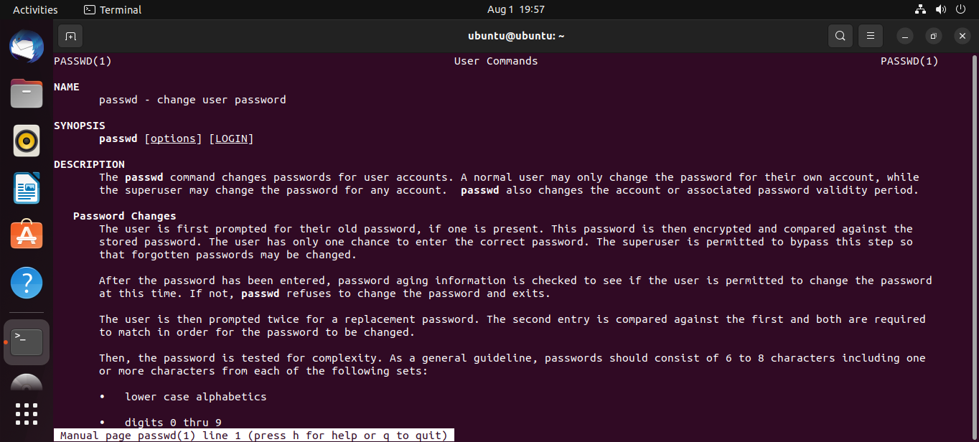

13.Display a list of all the commands that contain the keyword passwd in their man page.

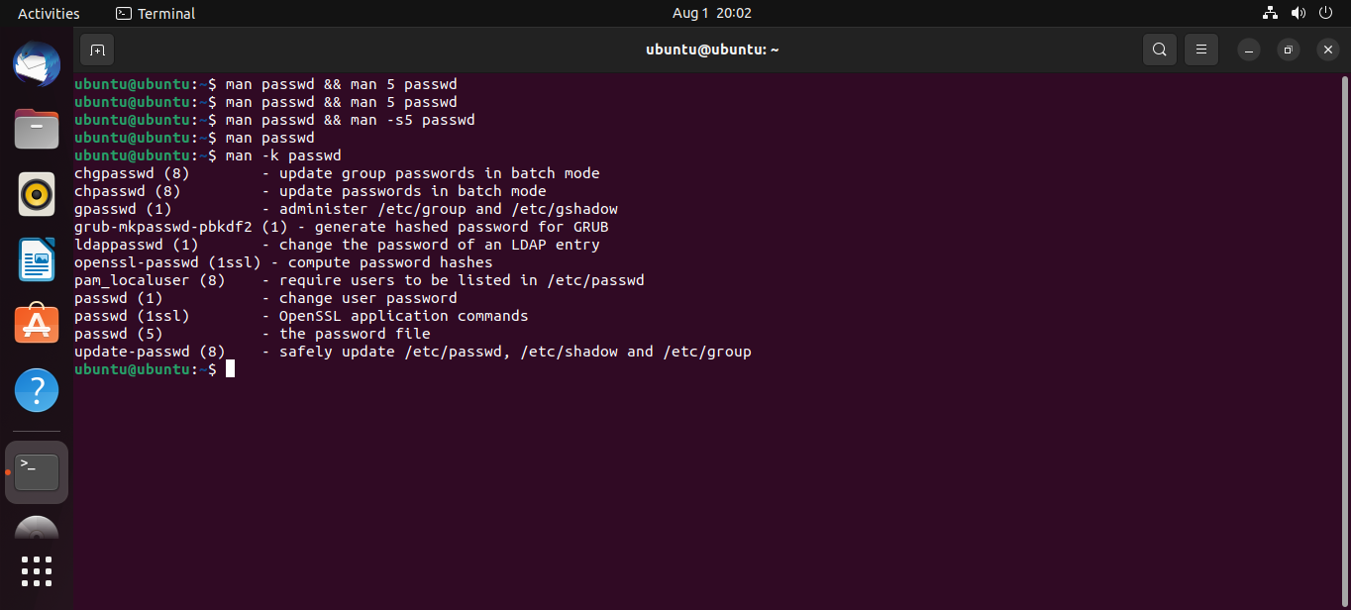

**Lab 2**

1. Create a user account with the following attribute

• username: islam

• Fullname/comment: Islam Askar

• Password: islam

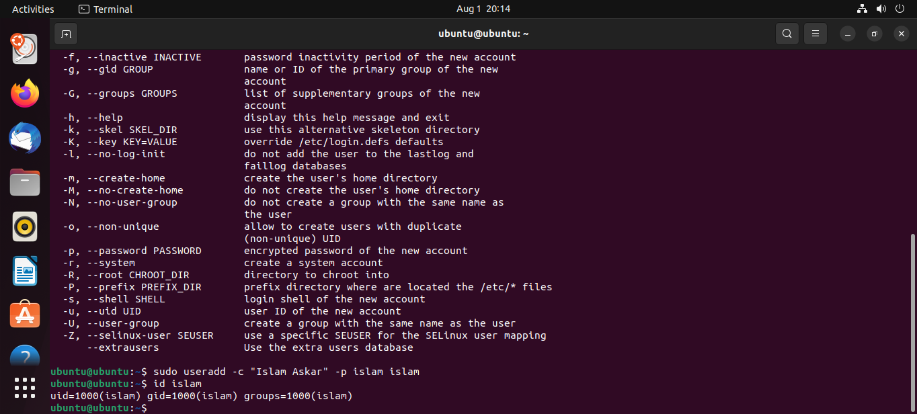

1. Create a user account with the following attribute

• Username: baduser

• Full name/comment: Bad User

• Password: baduser

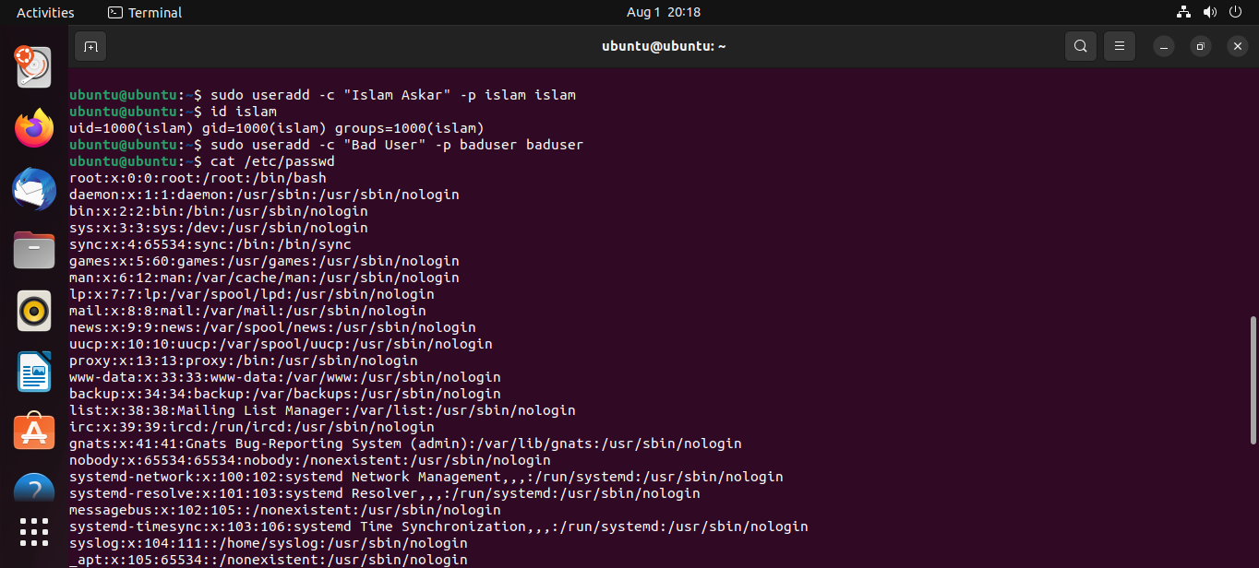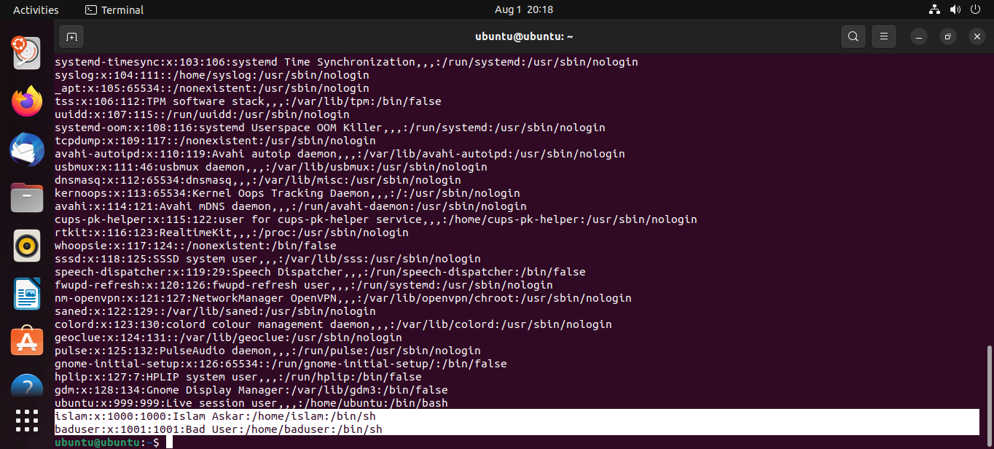

1. Create a supplementary (Secondary) group called pgroup with group ID of 30000
2. 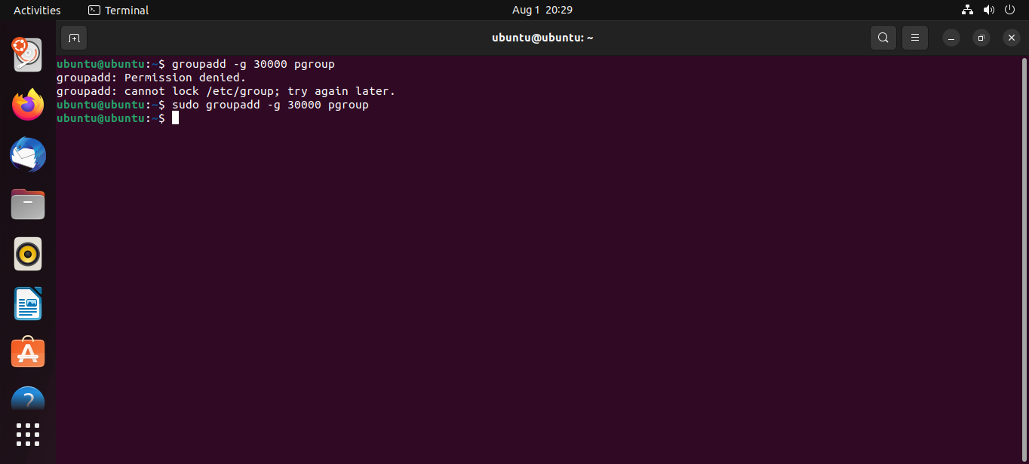Create a supplementary group called badgroup

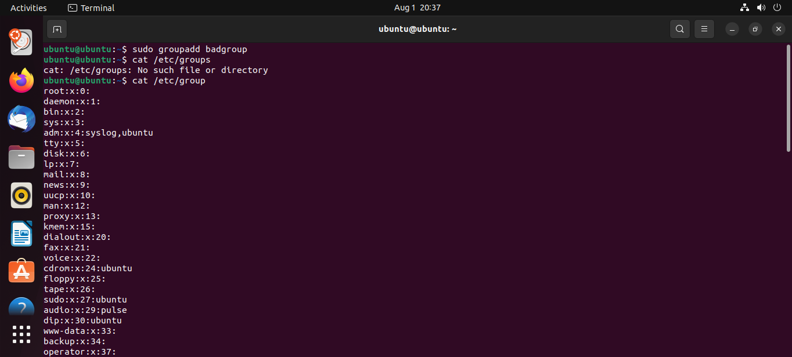

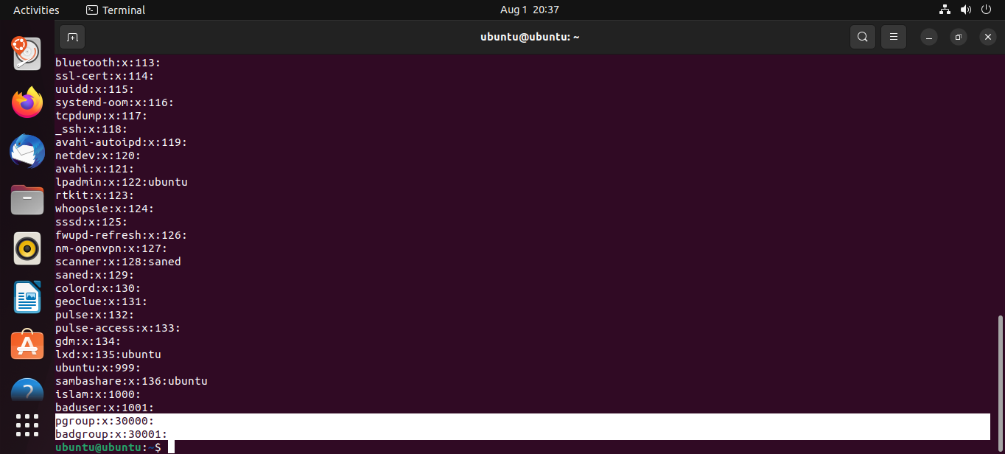

1. Add islam user to the pgroup group as a supplementary group

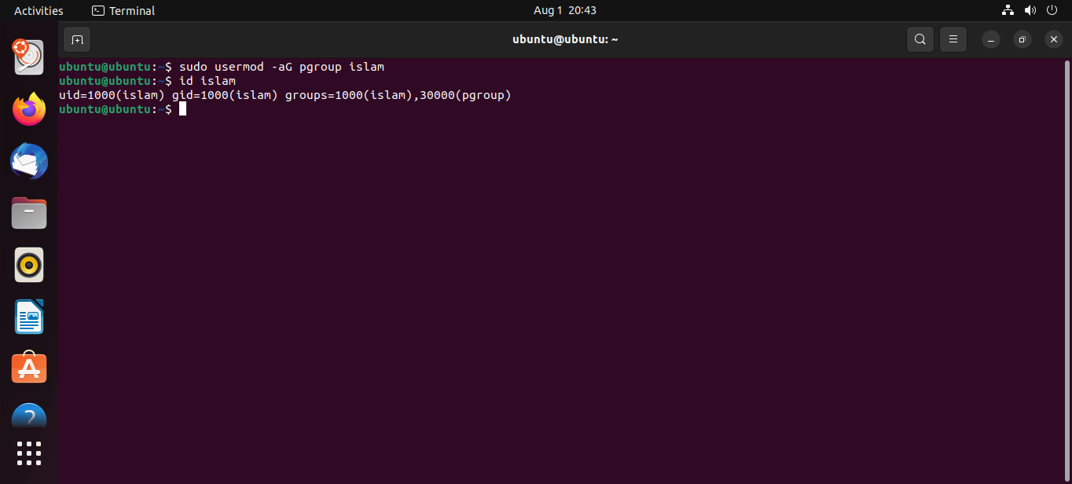

1. Modify the password of islam's account to password

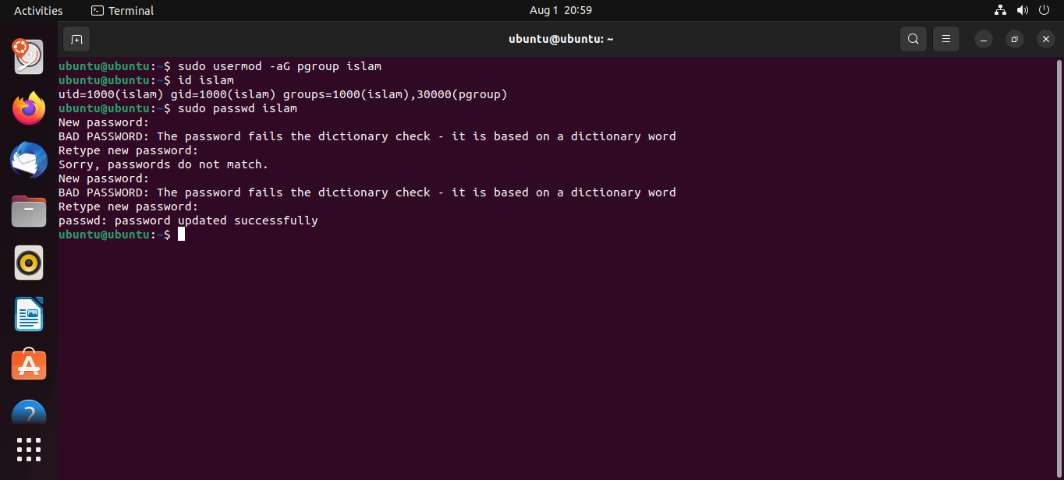

1. Modify islam's account so the password expires after 30 days

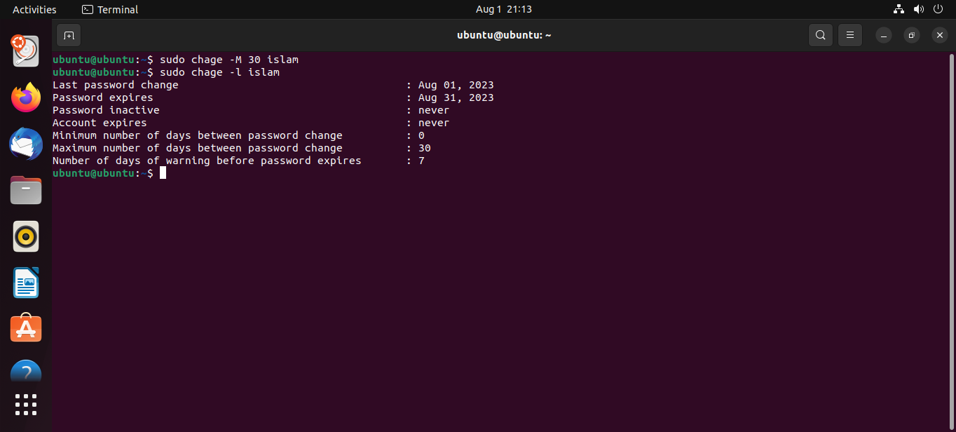

1. 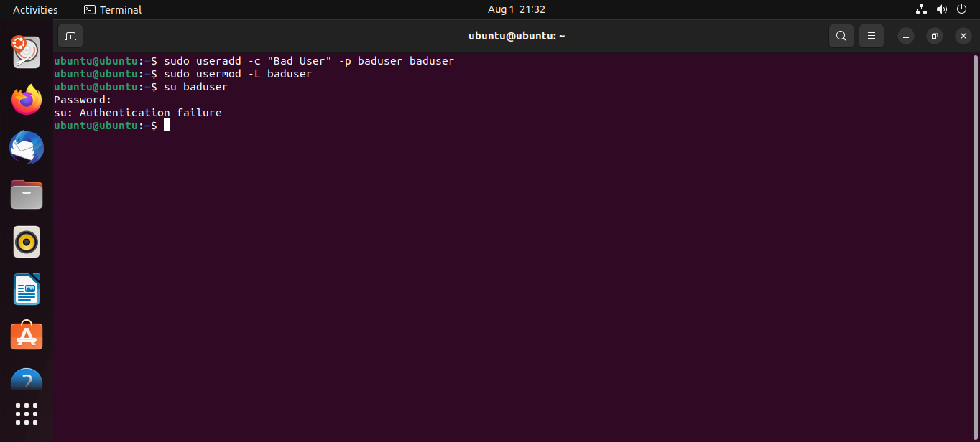Lock bad user account so he can't log in

9. Delete bad user account

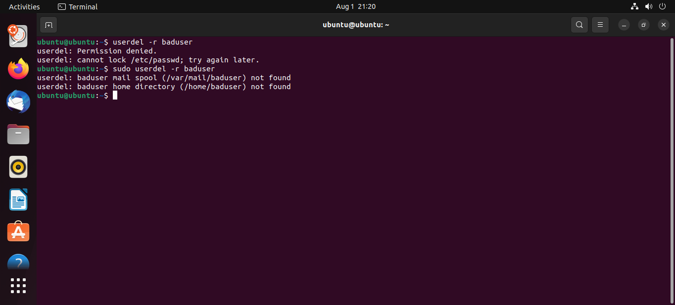

1. Delete the supplementary group called badgroup

